Test from Postman

Request | Postman (Screenshot) | S3 (Screenshot)
{  "action": "list"  } | https://prnt.sc/wWmhjK-0xu4U | https://prnt.sc/WgXYc4osV0Px
{  "action": "parce",  "keyword": "primary"  } | https://prnt.sc/KZMDGIm68Fft | https://prnt.sc/Ydjm8yaMNoex
{  "action": "show",  "file_name": "with_primary school_01-03-2024_08-41.csv"  } | https://prnt.sc/q6HSKy9KzQ00 | https://prnt.sc/oDLT5KCqhMMw
{  "action": "delete",  "file_name": "without_primary school_01-03-2024_11-34.csv"  } | https://prnt.sc/cWFQavXOmj0y | https://prnt.sc/hOLIFJ4dwbUN
{  "action": "delete by keyword",  "keyword": "castleton"  } | https://prnt.sc/XoR52Hx_1Chs | https://prnt.sc/_pS2d9M1394X
{  "action": "save by keyword",  "keyword": "primary"  } | https://prnt.sc/Zp9D4OqRJFfS | https://prnt.sc/uY7p1KCmxd_z
{  "data": {  "lat": 55.802,  "lon": -4.2512,  "radius": 4000,  "place_type": "school",  "no_keyword": "Primary"  }  } | https://prnt.sc/HQDmyraQwT2v  without primary schools | https://prnt.sc/gRln0XcVRKX3
{  "data": {  "lat": 55.802,  "lon": -4.2512,  "radius": 4000,  "place_type": "school",  "keyword": "Primary"  }  } | https://prnt.sc/SRlzh5TTs0cu  only primary schools | https://prnt.sc/kv3Sb9yeLuOn
{  "data": {  "lat": 55.802,  "lon": -4.2512,  "radius": 4000,  "place_type": "school"  }  } | https://prnt.sc/1NJNFHICwKgY | https://prnt.sc/oDLT5KCqhMMw

Automatic test from Postman

{  "action": "show",  "file_name": "with_primary school_01-03-2024_08-41.csv"  } | 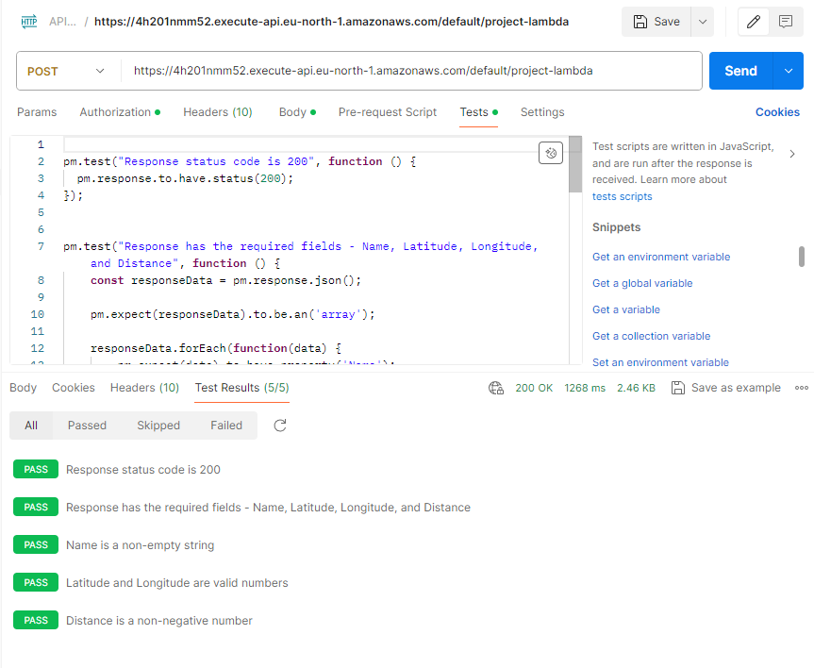
{  "action": "delete by keyword",  "keyword": "castleton"  } | 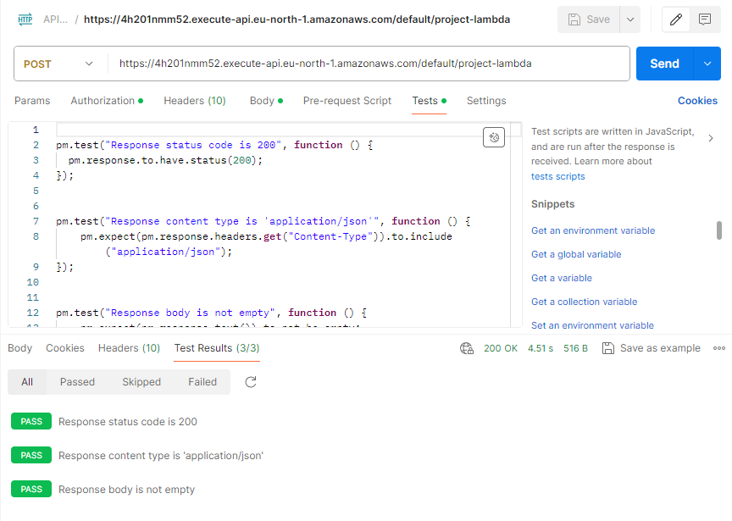
{  "action": "save by keyword",  "keyword": "primary"  } | 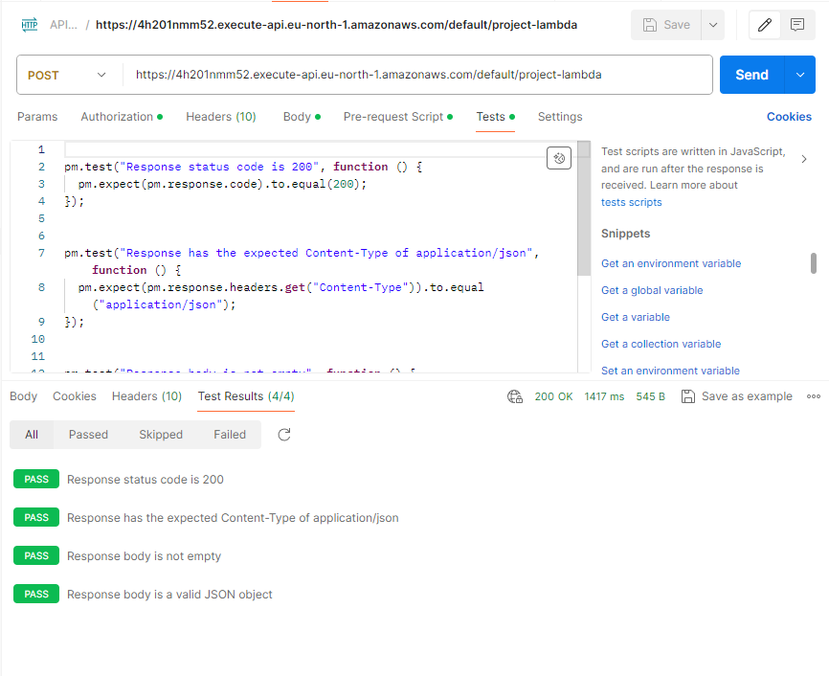
{  "data": {  "lat": 55.802,  "lon": -4.2512,  "radius": 4000,  "place_type": "school",  "no_keyword": "Primary School"  }  } | 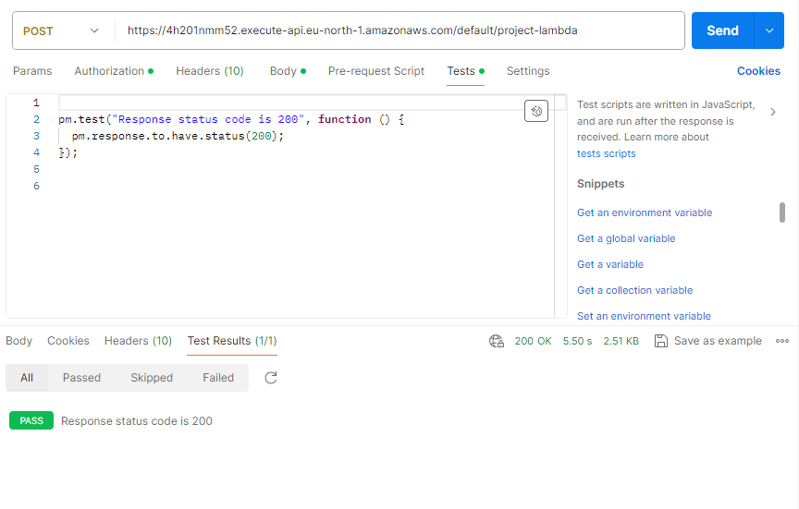
{  "data": {  "lat": 55.802,  "lon": -4.2512,  "radius": 4000,  "place_type": "school",  "keyword": "Primary School"  }  } | 
{  "data": {  "lat": 55.802,  "lon": -4.2512,  "radius": 4000,  "place_type": "school"  }  } | 

